micro Combined Heat and Power (CHP) Systems and Information

Information:
Oakland University SECS: https://www.oakland.edu/CHP
WiKipedia: https://en.wikipedia.org/wiki/Micro_combined_heat_and_power

Articles on micro CHP from 
http://www.cospp.com/topics/micro-chp-system.htm

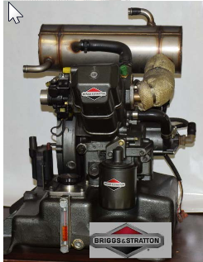
Manufacturers (available in the U.S.):

Marathon Engine (ecoPower)
Wisconsin USA
4.7kW unit Cost: ~$35,000 installed
long life, low emissions engine
http://www.marathonengine.com

https://youtu.be/WwgaZvIpibk
https://youtu.be/8QzbHpILqQY
https://youtu.be/vcaGQDstDug

MCogen
Houston, TX
6kW unit (new company, not sure about cost)
http://www.mcogen.com/
Spec sheet: http://www.mcogen.com/images/pdf/Mtrigenflyer.pdf#zoom=100

EC Power
Location: Denmark, with North American importer located near Toronto.
http://www.ecpower.eu/en/home.html
https://youtu.be/mCIPkmr5LY8
Sizes: 6kW, 8, 15, 20 (imported from Denmark)

Yanmar
Location: Japan
http://www.yanmar-es.com
Sizes: 5kW, 10, 25
Cost: 5kW unit ~$50,000 installed
https://youtu.be/rn631xZ-Olg
https://youtu.be/UgK9t3Gwo5k
Qnergy (Stirling Engine)
3.5 or 7.5kW stirling
Location: Israel, with new office in Ogden Utah
http://www.qnergy.com/-micro-chp-system
new company. not sure about cost or availability

Manufacturers (NOT available in the U.S.):
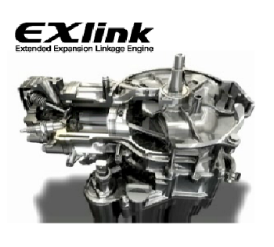

Honda EcoWill

http://world.honda.com/power/cogenerator/

http://world.honda.com/powerproducts-technology/cogeneration/

Photos of EcoWill engine and systems: (PLEASE VIEW THESE)
http://world.honda.com/news/2011/p110523Gas-Engine-Cogeneration/photo/

http://world.honda.com/news/2011/p110523Gas-Engine-Cogeneration/index.html

Honda Freewatt
US offering (out of business)
https://youtu.be/BsmEoDtoOME
https://youtu.be/-HWskiVkcf8
1.2 kW unit

Aisin
Location: Japan, with US office in Plymouth, MI
http://www.aisin.com/product/energy/
Sizes: 1.5kW and 6kW
not marketing in USA, but instead selling their gas engine driven heat pump systems.

Baxi EcoGen
Size: 1 kW Sterling Engine (attached to a HW heater, one of the MicroGen partners)
http://www.baxi.co.uk/renewables/combined-heat-and-power/ecogen.htm#horizontalTab2

https://youtu.be/xJbo3U3viRA
How it works: https://youtu.be/9UBbKWcWyVk (watch this one)
At a trade show: https://youtu.be/XRUrxVaA1T4

http://www.microgen-engine.com/

Other:

WhisperGen - stirling engine from New Zeland (out of business due to earthquake)

Solid Oxide fuel cell options (some are commercially available in Japan & Europe)

Rakine Cycle options (I have seen some R&D / startup companies)

Brayton Cycle Options: Micro turbine unit from Ener Twin http://www.enertwin.com/
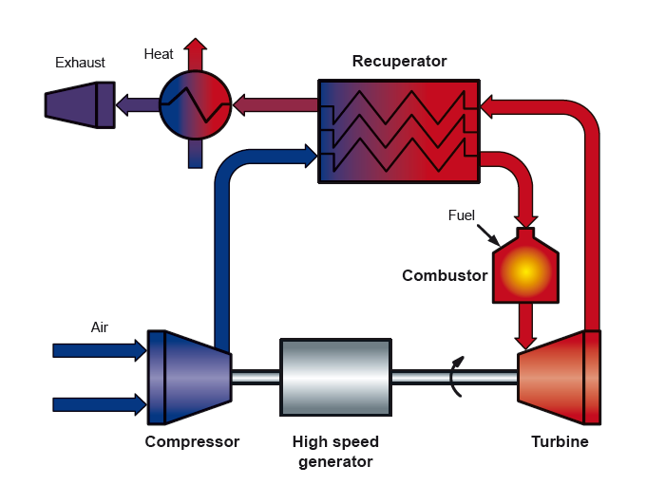

Capstone Turbine: Larger 30kW, 60 and 200. Oakland has two of the 200kW units installed in the Engineering Center in a CHP configuration. Single shaft runs on air bearings.
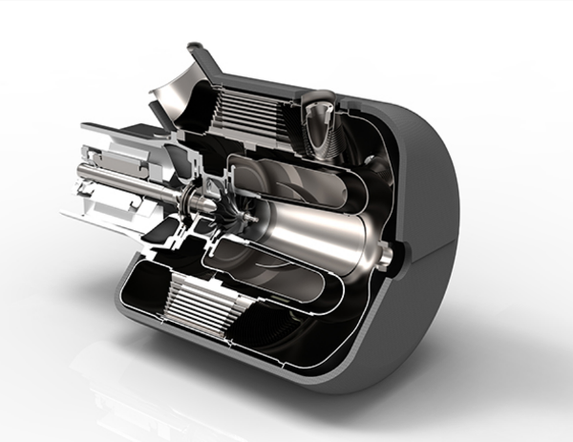
http://www.capstoneturbine.com/

https://youtu.be/M-ICC1Es9KY (animation)

